

**Game Design Summary**

**Produced by: The A Team**

Matthew Kaptur, Oliver Slape, Bec Nash, Daniel Edson, Codrin Axinte

17-10-17

*a game production by*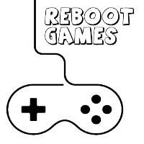

**GAME OVERVIEW**

**I. Introduction**

In this 2D web application game, the player(s) will participate in four educational mini games to help save the world whilst learning about the effects of greenhouse gases on the world. The app also provides a closer look at the greenhouse gases timeline for four products; mobile phones, beef, leaving electronic devices on standby and plastic bottles.

**II. Objective of the Game**

The objective of the game is to restore the map of the world, and reduce the greenhouse gas meter from red to green by participating in each of the four mini games.

Mini game 1: British Countryside – Beef

A Snake style maze game in which the player must move their character to eat the vegetables and avoid the beef.

Mini game 2: Ocean – Plastic Bottles

A basketball style game in which the player must throw plastic bottles into the recycling bin.

Mini game 3: Rainforest – Mobile Phone

A collection style game in which working mobile phones, and broken mobile phones fall from the top of the screen where the player must catch the broken phones in the recycling bin, and working phones into the backpack.

Mini game 4: Arctic – Leaving electronic devices on standby

A game in which players must unplug and turn off switches for electronic devices.

**III. Genre**

Action-educational puzzle game.

**VI. Features**

* 2D game
* Team play
* Visual feedback
* Educational
* Interactive
* Real-time updates

## V. Platform

This game will be a web-based application, designed for use with on an Apple iPad.

## VI. Intended Audience

The intended audience of this game is for casual or non-gamers of both genders from the age of 11 to 16, however the primary age range is 11 to 12 years old.

## VII. Language

The game will only be in English.

## VIII. Sound Consideration

The game play experience is not dependant on sound and as such the game does not require speakers of any kind.

# **STORY**

## I. Outline

The story revolves around saving the world from the effects of the greenhouse gases that are emitted during the production of four products; mobile phones, beef, leaving electronic devices on standby and plastic bottles. Each mini game that is completed will reward players with points that will help them to save the world.

## II. Story Synopsis

The world is in a very bad way, with the arctic sea ice mostly melted away, black smog covering the British countryside, rainforests at half their size and bleached coral covering the ocean floor. With the help of the students, actions can be taken to save the future state of the world, but there’s only 20-minutes. Will action be taken? Will we save the world? That’s down to you.

## III. Cut Scene Screens

Opening Cut Scenes

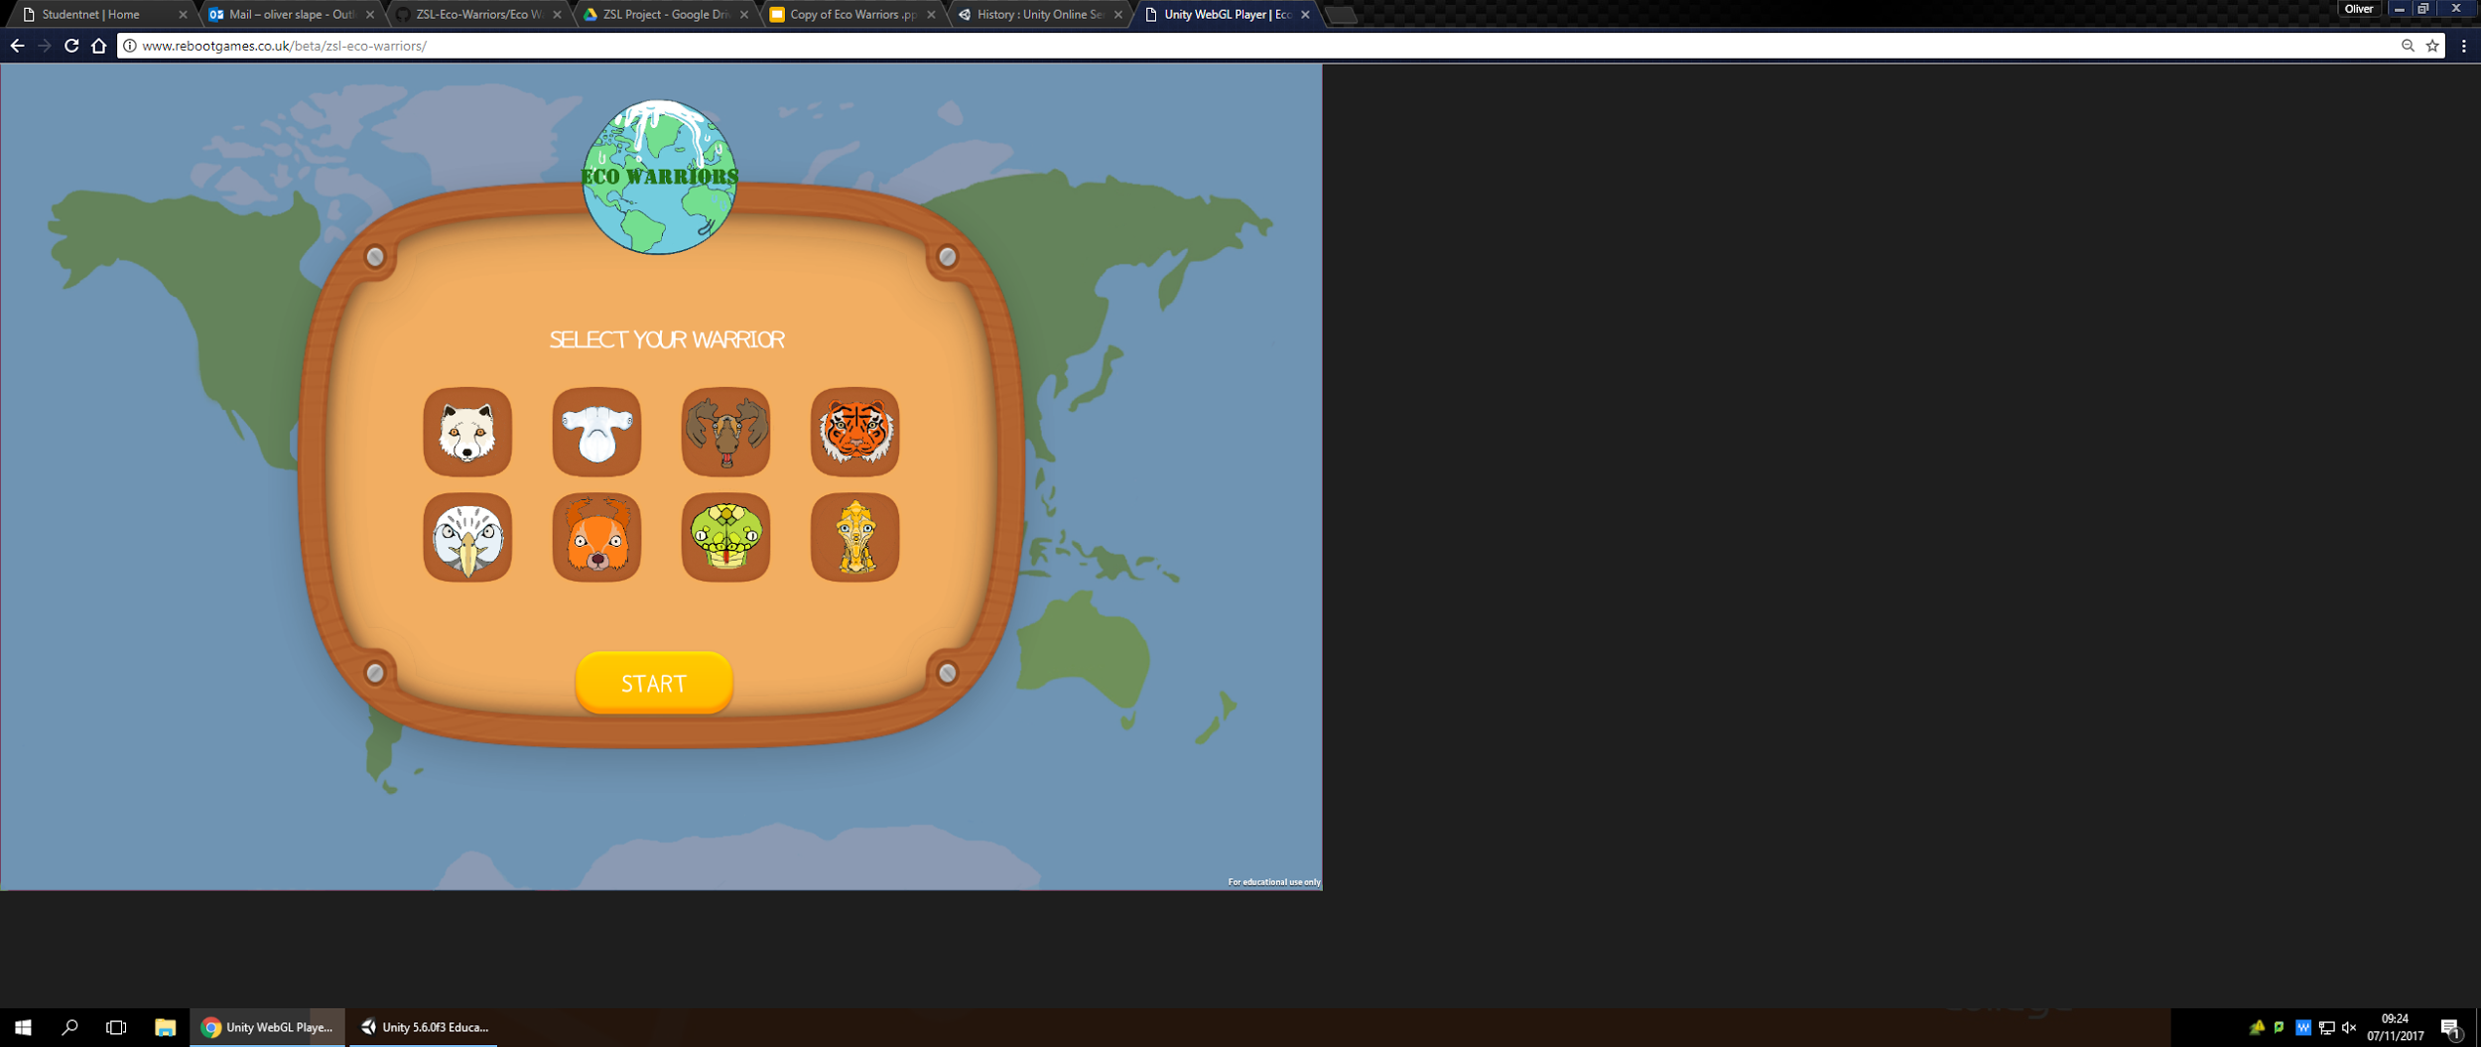

1. The opening window for team registration and character selection

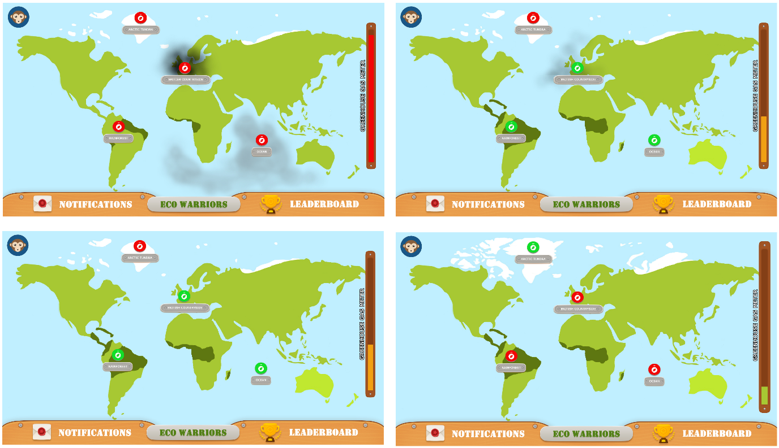

1. Launch of game world map in its worst condition; melted ice caps, rainforest deforestation, bleached ocean coral and a smoggy countryside. Greenhouse gas meter displays as red.

2. World map after successful completion of the rainforest and ocean mini game. Countryside game complete but displaying partial clearance based on in game performance; condition improvements to three habitats. Greenhouse gas meter is amber.

3. World map after successful completion of the rainforest, ocean and countryside mini game; full improvement to three habitats. Greenhouse gas meter is amber.

4. World map after successfully completing all four mini games; full restoration of the world. Greenhouse gas meter is green.

Mini Game Scenes

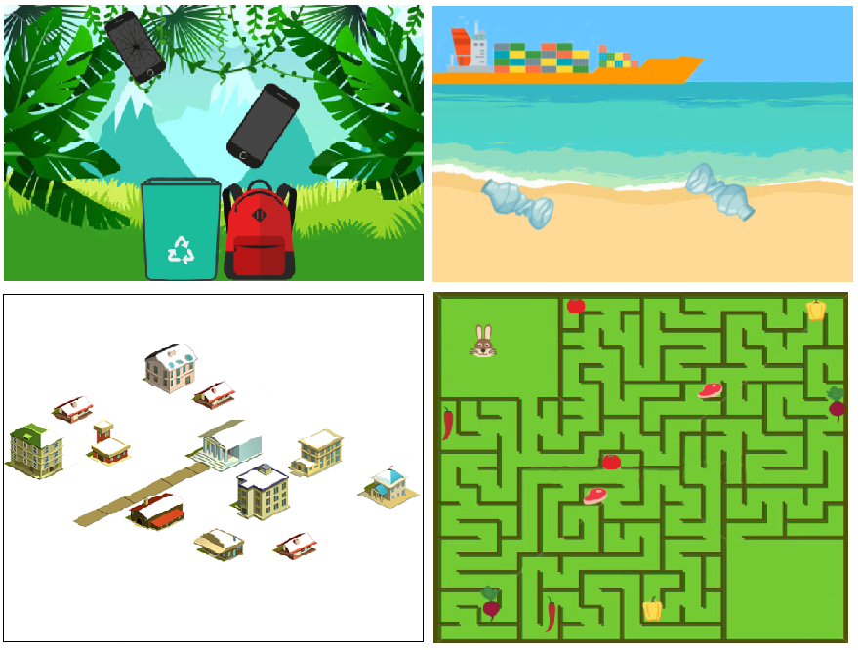

1. Rainforest  
  
2. Ocean  
  
3. Arctic Tundra  
  
4. British Countryside

Ending Cutscenes

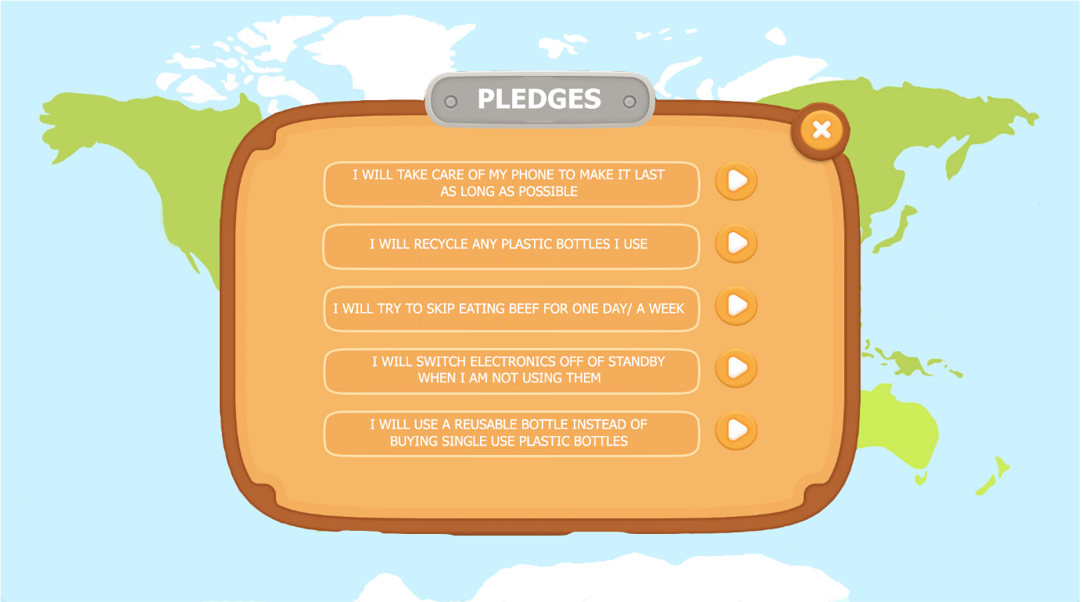

1. Entry window for recording of top 3 pledges, chosen from predefined list

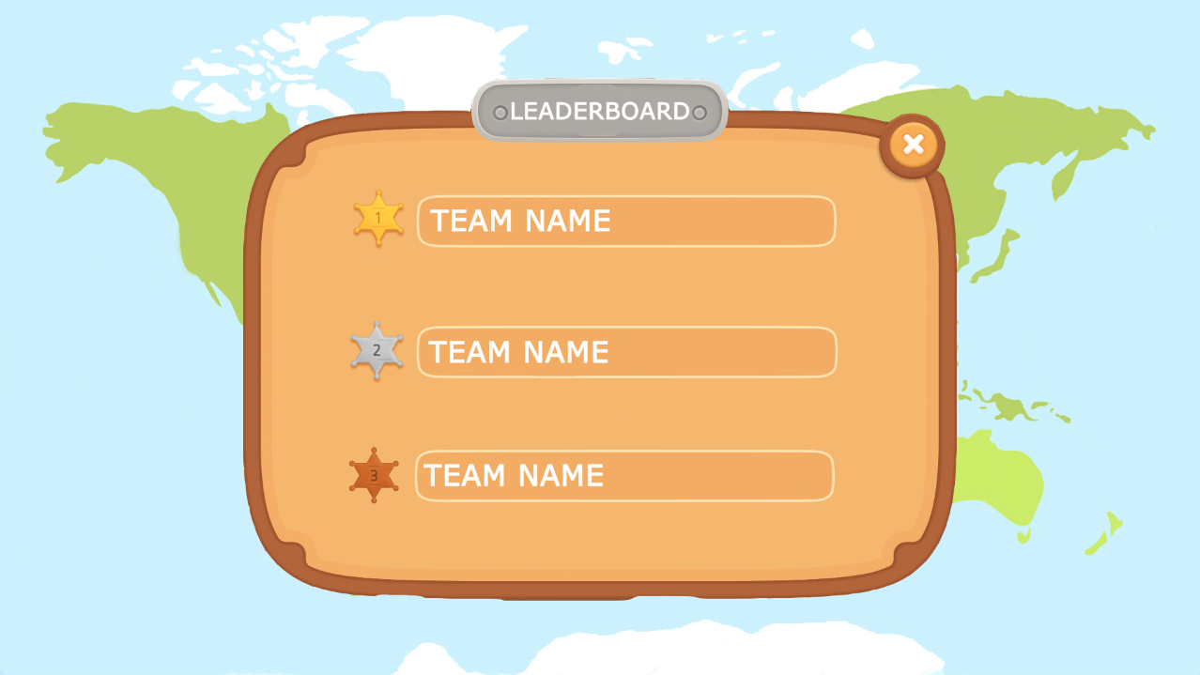

1. Leaderboard, displaying top 3 ranked teams

# **CORE GAME MECHANICS**

## I. Team Play

This game will be played in teams. The app will prompt play to swap to other team members throughout the game.

## II. General Movement

The player(s) may choose to drag-and-drop, swipe and tap within the game, with different styles of movement being applicable to different scenes within the game.

## III. Initial Setup

The web app opens with a request for the team to create a team name and select an animal character of their choice. A ‘start’ button will move them into the world map view, where the world is displayed in its worst condition having been destroyed by climate change.

# **CHARACTERS**

Arctic Tundra Characters

Arctic Fox

Moose

Rainforest Characters

Sumatran Tiger

Emerald Tree Boa

Ocean Characters

Hammerhead Shark

Longsnout Seahorse

British Countryside Characters

Red Kite

Red Squirrel